Visitation Policy

It is the policy of the Cape West to sensitively respond to residents’ individual needs and wishes regarding visitation of their family and friends while maintaining a safe and restful environment, and to ensure consistency and satisfaction in all residents and guest interactions in compliance with state law. This policy is designed to support the “No Patient Left Behind Act”. As part of this visitation policy, visitors cannot be compelled to provide proof of vaccination or immunization status.

Visitation Policy:

- Visitation may occur 365 days a year between the hours of 9am -9pm. Hours may be extended for visitors from out of town.
- Visitation may occur in the resident’s room, outdoor facility spaces, or common area.
- Children visiting Cape West residents should be supervised by adults at all time.
- Residents are not limited in how many visitors they can have per day.
- No more than 3 visitors per resident at a time.
- All visitors are required to sign-in and if taking a resident outside of the facility, will
need to let the staff know when they will be back.
- The visitor log asks for the phone number of the person taking the resident outside of the facility. It is required to be filled out.
Essential Caregiver:

- Designation determined by resident naming a family member, friend, guardian, or other individual as an essential caregiver. An essential caregiver can provide emotional support to help a resident deal with any of the following circumstances:
- End of life situations
- Making one or more major medical decisions
- Coping with emotional distress or grieving the loss of a friend or family member who recently died.
- Residents needing encouragement to eat or drink which was previously provided by a family member or caregiver.
- Helping resident to continue to talk and interact with others.

- Per Florida Statute 408.823 (2)(B) A resident, client, or patient may designate a visitor who is a family member, friend, guardian, or other individual as an essential caregiver. The provider must allow in-person visitation by the essential caregiver for at least 2 hours daily in addition to any other visitation authorized by the provider. This section does not require an essential caregiver to provide necessary care to a resident, client, or patient of a provider, and providers may not require an essential caregiver to provide such care.

Other Facilities:

- Please have family member notify us of your visit 24 hours ahead of time
- An appointment is required with the Manager
- On the day of your visit, please present your business card at time of visit
- Only speak with the resident you are there to visit and do so privately
- We appreciate your cooperation and communication

Infection Control Policy and Procedures:

It is the policy of Cape West Assisted Living Facility, pursuant to Rule 59A-36.007(10), F.A.C.to provide services in a manner that reduces the risk of transmission of infectious diseases. This facility implemented an Infection Control and Hand Hygiene Program. Infection Control includes all those activities to prevent or limit the spread of diseases. Infection control measures are safety measures. Hand hygiene may include the use of alcohol-based rubs, antiseptic hand wash, and/or hand washing with soap and water. This is the single most important means of preventing the spread of infections in the facility.

- The person responsible for making sure the visitation and infection control/PPE policy is enforced, is the senior staff member on duty.

- Hand Hygiene Policy and Procedures:

- Employee’s hands must be washed for at least 20 seconds using soap and water.
- Before and after the provision of personal services to residents.
- After contact with blood, body fluids, or visibly contaminated surfaces.
- After contact with objects and surfaces in the resident's environment.
- After removing Personal Protective Equipment (gloves, gown, facemask, eye protection, etc.).
- After using the restroom.
- After blowing one's nose, sneezing, or coughing.
- Before eating or preparing food.
- When their hands are visibly soiled.
- At the beginning and the end of each shift.
- After contact with animals or pets.

- Personal Protective equipment:

- Defined as equipment or devices to maintain the safety of the individual or others.
- Personal protective equipment may include: face masks, respirators, face shields, gloves, and gowns.

- Use personal protective equipment (PPE) whenever there is an expectation of possible exposure to infectious material
- Follow respiratory hygiene/cough etiquette principles
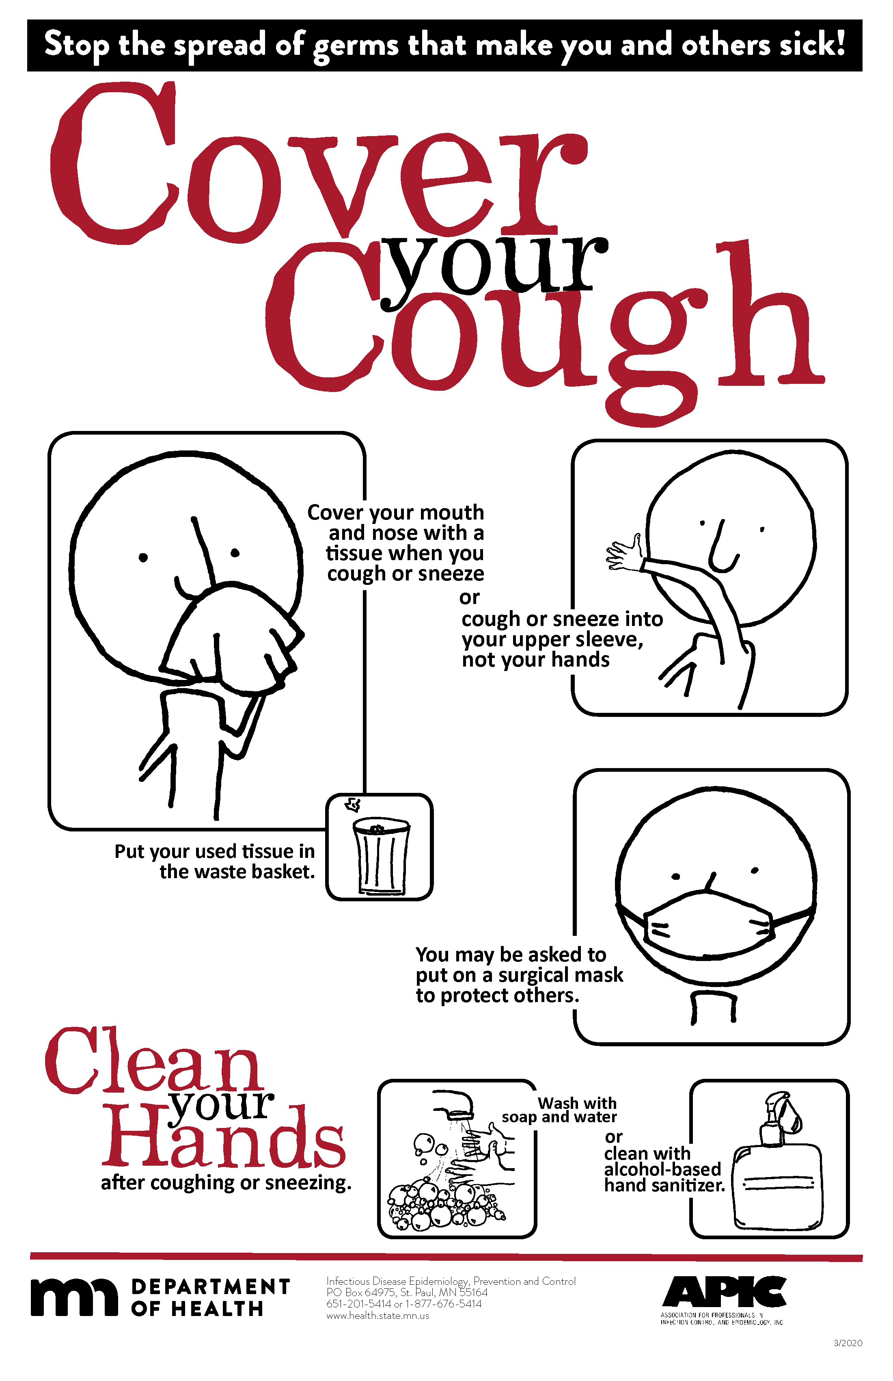
- Properly handle and properly clean and disinfect patient care equipment and instruments/devices
- Dispose of needles in sharps containers (once containers are at the full line, they will be taken to the nearest fire department for disposal);

C. Residents should always wash their hands at least 20 seconds using soap and water: (The combination of soap and water, friction and time is essential to any good hand washing procedure)
1. Before meals.
2. After toileting.

D. Standard precautions:

Must be used when there is an anticipated exposure to transmissible infectious agents in blood, body fluids, secretions, excretions, nonintact skin, and mucous membranes during the provision of personal services.

1. Standard precautions include hand hygiene, and dependent upon the exposure, the use of gloves, gown, facemask, eye protection, and/or a face shield.
2. Provide access to alcohol-based hand sanitizer with 60-95% alcohol throughout the
facility in every resident room and common areas. If there are shortages of alcohol-based hand sanitizer, hand hygiene using liquid soap and water is still expected. Keep sinks stocked with liquid soap and disposable paper towels.
3. Communicate to residents about what they need to do - such as social distancing, wear a cloth face covering or facemask, informing personnel immediately if they feel ill, importance of washing their hands, avoiding touching their face, and cough etiquette.
4. Provide EPA-registered disinfectant so that commonly used surfaces can be wiped
down. Routinely (at least once per shift) clean and disinfect surfaces and objects that are frequently touched in common areas (door handles, faucets, toilet handles, light switches, handrails, countertops, chairs, tables, remote controls, shared electronic equipment).
5. The facility must clean and disinfect reusable medical equipment and communal assistive devices that have been designed for use by multiple residents before and after each use according to the manufacturer's recommendations.
6. Visitors should be aware that these safety measures are for their safety, residents' safety, and the safety of team members.
7. The Manager of Cape West Assisted Living Facility is the staff member designated to contact with questions that are not answered in this Visitation Policy.
8. The facility asks that the visitors refrain from transporting soiled or potentially infected laundry.

Communicable Disease Guidelines
- Infection control and education policies for visitors
- Cape West is teaching the visitors ways to prevent the spread of communicable diseases.
- Visitors to Cape West will learn the proper way to wash their hands while visiting the facility.
- Visitors will also learn the proper way to wear personal protective equipment.
- Cape West has sings around the facility teaching visitors how to prevent the spread of infection diseases.

- Screening, personal protective equipment, and other infection control protocols for visitors.
- Visitors to Cape West will signing in and out.
- Visitors will be screened for symptoms when they sign in.
- Cape West will providing personal protective equipment in case the visitor does not have them
- Cape West will convey to visitors to bring their own personal protective equipment (PPE) prior to their visits.

Visitation When a Resident Is Sick
When a resident is experiencing an illness or symptoms of a potentially contagious condition, Cape West will take reasonable precautions to protect the health and safety of residents, visitors, and staff while continuing to respect residents’ visitation rights.
Depending on the resident’s condition and the potential risk of transmission, Cape West may:
- Inform visitors of appropriate precautions before entering the resident’s room.
- Encourage or require appropriate infection-control measures, such as hand hygiene and the use of personal protective equipment (PPE), when necessary.
- Provide visitors with instructions regarding any applicable infection-control precautions.
- Encourage visits to take place in the resident’s room or another appropriate area to reduce unnecessary exposure to other residents.
- Increase cleaning and disinfection of frequently touched surfaces and affected areas.
- Follow applicable infection-control guidance and requirements from AHCA and other public health authorities.
Cape West will make reasonable efforts to balance infection prevention with each resident’s right to receive visitors.
Essential caregivers will continue to be permitted access in accordance with applicable law and Cape West policy and will not be required to leave solely because the resident is sick. Essential caregivers may be required to follow reasonable infection-control precautions necessary to protect the resident, other residents, and staff.

- The Administrator is the designated person responsible for staff adherence to visitation policies and procedures.

- Consensual physical contact are allowed between a resident and a visitor.

