**Visitation Policy**

It is the policy of the Cape West to sensitively respond to residents’ individual needs and wishes regarding visitation of their family and friends while maintaining a safe and restful environment, and to ensure consistency and satisfaction in all residents and guest interactions in compliance with state law. This policy is designed to support the “No Patient Left Behind Act”. As part of this visitation policy, visitors cannot be compelled to provide proof of vaccination or immunization status.

**Visitation Policy:**

* Visitation may occur 365 days a year between the hours of 9am -9pm. Hours may be extended for visitors from out of town.
* Visitation may occur in the resident’s room, outdoor facility spaces, or common area.
* Children visiting Cape West residents should be supervised by adults at all time.
* Residents are not limited in how many visitors they can have per day.
* No more than 3 visitors per resident at a time.
* All visitors are required to sign-in and if taking a resident outside of the facility, will

need to let the staff know when they will be back.

* The visitor log asks for the phone number of the person taking the resident outside of the facility. It is required to be filled out.
* If you are running a fever, vomiting or having diarrhea, you may not visit until those symptoms have passed for a minimum of 24 hours.
* If you have a cold, you may not visit until those symptoms have passed for a minimum of 24 hours.

**Essential Caregiver:**

* Designation determined by resident naming a family member, friend, guardian, or other individual as an essential caregiver. An essential caregiver can provide emotional support to help a resident deal with any of the following circumstances:
* End of life situations
* Making one or more major medical decisions
* Coping with emotional distress or grieving the loss of a friend or family member who recently died.
* Residents needing encouragement to eat or drink which was previously provided by a family member or caregiver.
* Helping resident to continue to talk and interact with others.

**Other Facilities:**

* Please have family member notify us of your visit 24 hours ahead of time
* An appointment is required with the Manager
* On the day of your visit, please present your business card at time of visit
* Only speak with the resident you are there to visit and do so privately
* We appreciate your cooperation and communication

**Infection Control Policy and Procedures:**

It is the policy of **Cape West Assisted Living Facility,** pursuant to Rule 59A-36.007(10), F.A.C.to provide services in a manner that reduces the risk of transmission of infectious diseases. This facility implemented an Infection Control and Hand Hygiene Program. Infection Control includes all those activities to prevent or limit the spread of diseases. Infection control measures are safety measures. Hand hygiene may include the use of alcohol-based rubs, antiseptic hand wash, and/or hand washing with soap and water. This is the single most important means of preventing the spread of infections in the facility.

* The person responsible for making sure the visitation and infection control/PPE policy is enforced, is the **senior staff member on duty**.

1. **Hand Hygiene Policy and Procedures:**
2. Employee’s hands must be washed for at least 20 seconds using soap and water.
3. Before and after the provision of personal services to residents.
4. After contact with blood, body fluids, or visibly contaminated surfaces.
5. After contact with objects and surfaces in the resident's environment.
6. After removing Personal Protective Equipment (gloves, gown, facemask, eye protection, etc.).
7. After using the restroom.
8. After blowing one's nose, sneezing, or coughing.
9. Before eating or preparing food.
10. When their hands are visibly soiled.
11. At the beginning and the end of each shift.
12. After contact with animals or pets.
13. **Personal Protective equipment:**
14. Defined as equipment or devices to maintain the safety of the individual or others.
15. Personal protective equipment may include: face masks, respirators, face shields, gloves, and gowns.
16. Use personal protective equipment (PPE) whenever there is an expectation of possible exposure to infectious material
17. Follow respiratory hygiene/cough etiquette principles

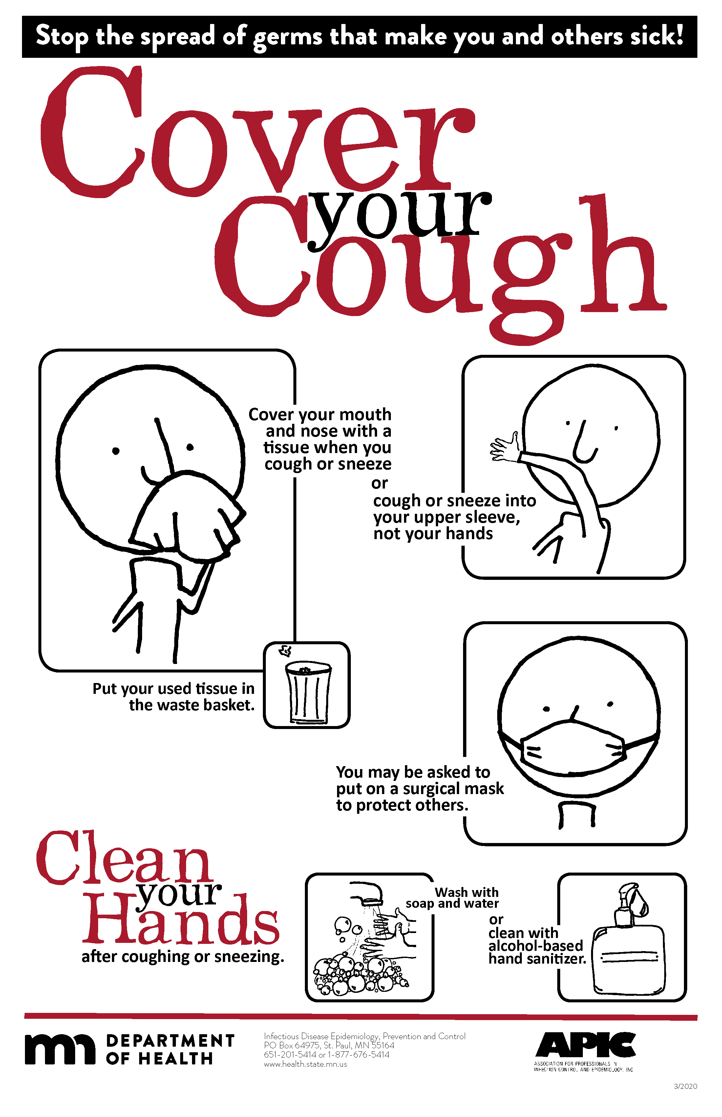

1. Properly handle and properly clean and disinfect patient care equipment and instruments/devices
2. Dispose of needles in sharps containers (once containers are at the full line, they will be taken to the nearest fire department for disposal);

**C. Residents should always wash their hands at least 20 seconds using soap and water**: (The combination of soap and water, friction and time is essential to any good hand washing procedure)

1. Before meals.

2. After toileting.

**D. Standard precautions**:

Must be used when there is an anticipated exposure to transmissible infectious agents in blood, body fluids, secretions, excretions, nonintact skin, and mucous membranes during the provision of personal services.

1. Standard precautions include hand hygiene, and dependent upon the exposure, the use of gloves, gown, facemask, eye protection, and/or a face shield.

2. Provide access to alcohol-based hand sanitizer with 60-95% alcohol throughout the

facility in every resident room and common areas. If there are shortages of alcohol-based hand sanitizer, hand hygiene using liquid soap and water is still expected. Keep sinks stocked with liquid soap and disposable paper towels.

3. Communicate to residents about what they need to do - such as social distancing, wear a cloth face covering or facemask, informing personnel immediately if they feel ill, importance of washing their hands, avoiding touching their face, and cough etiquette.

4. Provide EPA-registered disinfectant so that commonly used surfaces can be wiped

down. Routinely (at least once per shift) clean and disinfect surfaces and objects that are frequently touched in common areas (door handles, faucets, toilet handles, light switches, handrails, countertops, chairs, tables, remote controls, shared electronic equipment).

5. The facility must clean and disinfect reusable medical equipment and communal assistive devices that have been designed for use by multiple residents before and after each use according to the manufacturer's recommendations.

6. Visitors should be aware that these safety measures are for their safety, residents' safety, and the safety of team members.

7. The Manager of Cape West Assisted Living Facility is the staff member designated to contact with questions that are not answered in this Visitation Policy.

8. The facility asks that the visitors refrain from transporting soiled or potentially infected laundry.

9. The facility asks that the visitors refrain from visiting when sick or when they have a communicable disease.

**COVID-19 Guidelines:**

**If you have had “Close Contact” with a person positive with COVID-19:**

I’m “up to date” on my vaccinations or I am unvaccinated or not up-to-date

* You do not need to stay home unless you develop symptoms.
* Watch for symptoms of COVID-19 and wear a well-fitting mask until 10 days have passed after you last had close contact with someone with COVID-19. CDC recommends even if you don’t develop symptoms, to get tested at least 5 days after last close contact with someone with COVID-19.
* If you develop symptoms, isolate immediately and get tested. If you develop symptoms, let your manager know.
* If positive, follow guidelines for testing positive below.
* Quarantine for 5 days from your last contact with the positive person.
* Return to work on the 6th day from your last contact with the positive person.

**If you are positive with COVID-19:**

* Regardless of vaccination status, isolate for 5 days from your positive test result.
* End isolation if you had symptoms after 5 full days if you are fever-free for 24 hours (without the use of fever-reducing medications) and your symptoms are improving.
* Ending isolation if you did NOT have symptoms after 5 full days after your positive test result.
* Wear a well-fitting mask for 10 full days when you are around others.

**If you have symptoms of COVID-19 (no known exposure or positive COVID-19 test):**

* Do not report to work with any symptoms of COVID-19.
* If experiencing symptoms, it’s recommended that you be tested
* You may return to work once you have a negative test result

**Definitions:**

**Close contact**- someone who was less than 6 feet away from an infected person (laboratory- confirmed or a clinical diagnosis) for a cumulative total of 15 minutes or more over a 24-hour period regardless if they are wearing a cloth mask. For example, 3 individual 5-minute exposures for a total of 15 minutes. People who are exposed to someone with COVID-19 after they completed at least 5 days of isolation are not considered close contacts.

**Up-to-date:** You are up to date with your COVID-19 vaccines when you have received all doses in the primary series and all boosters recommended for you, when eligible.

**Calculating Isolation Time:**

Day 0 is your first day of symptoms or a positive viral test. Day 1 is the first full day after your symptoms developed or your test specimen was collected.

**Calculating Quarantine**:

The date of your exposure is considered day 0. Day 1 is the first full day after your last contact with a person who has had COVID-19.